**Greenhouse Gasses, Climate Change and US Oil & Gas Production Expansions**

Deliverable Product from Students, due Thursday October 24 at start of class: A 150 to 250 word summary of all of the materials below, for up to 10 participation points. Be prepared to discuss.

1. Greenhouse Gasses

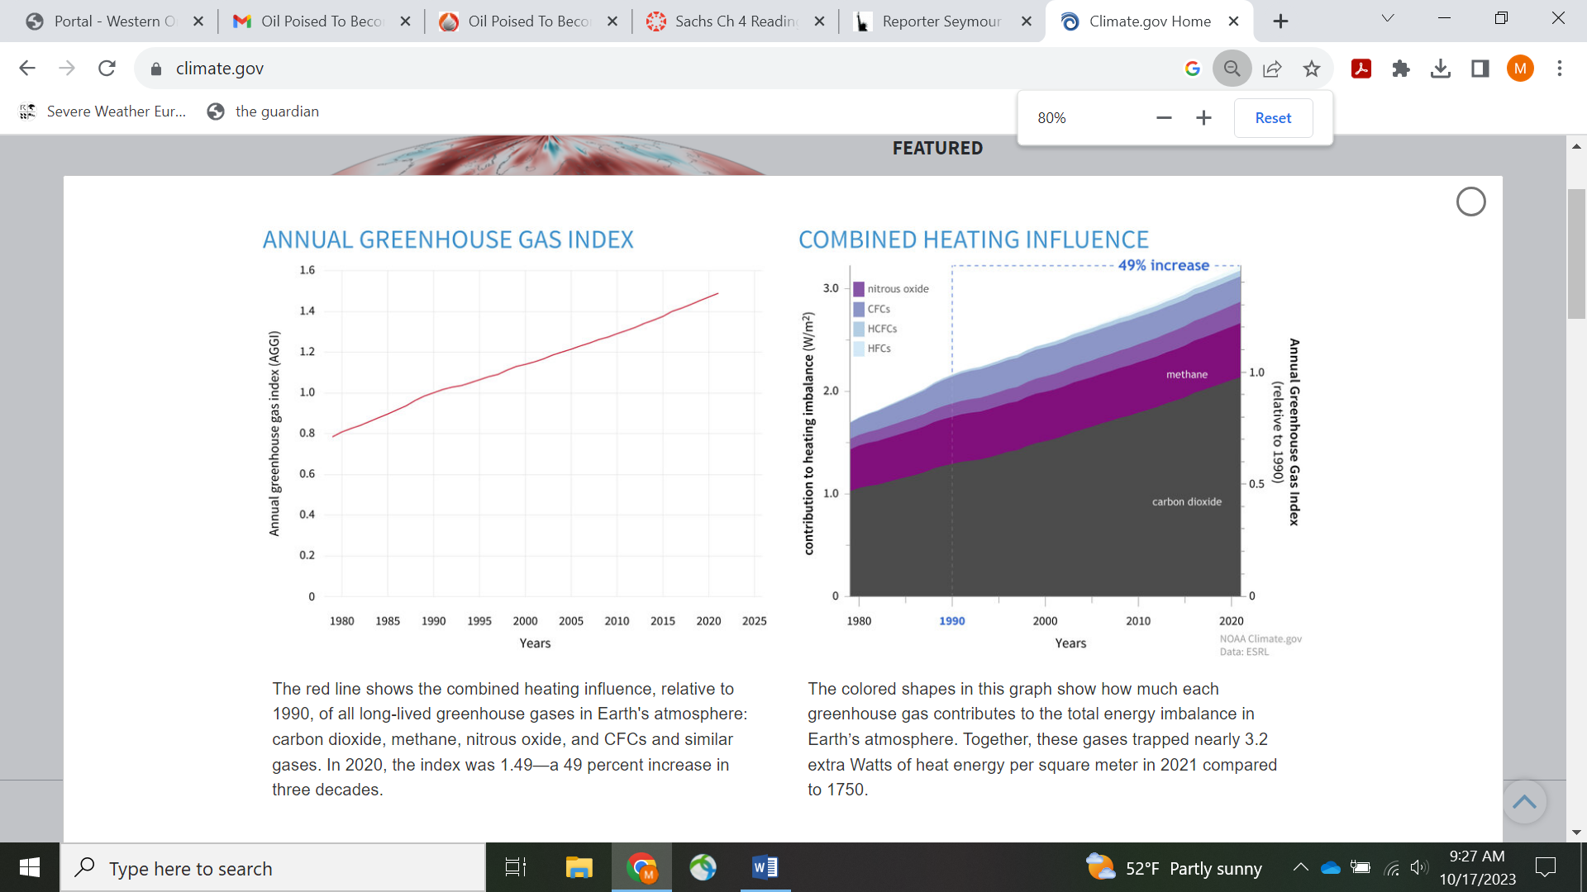

2. Temperature Trends:

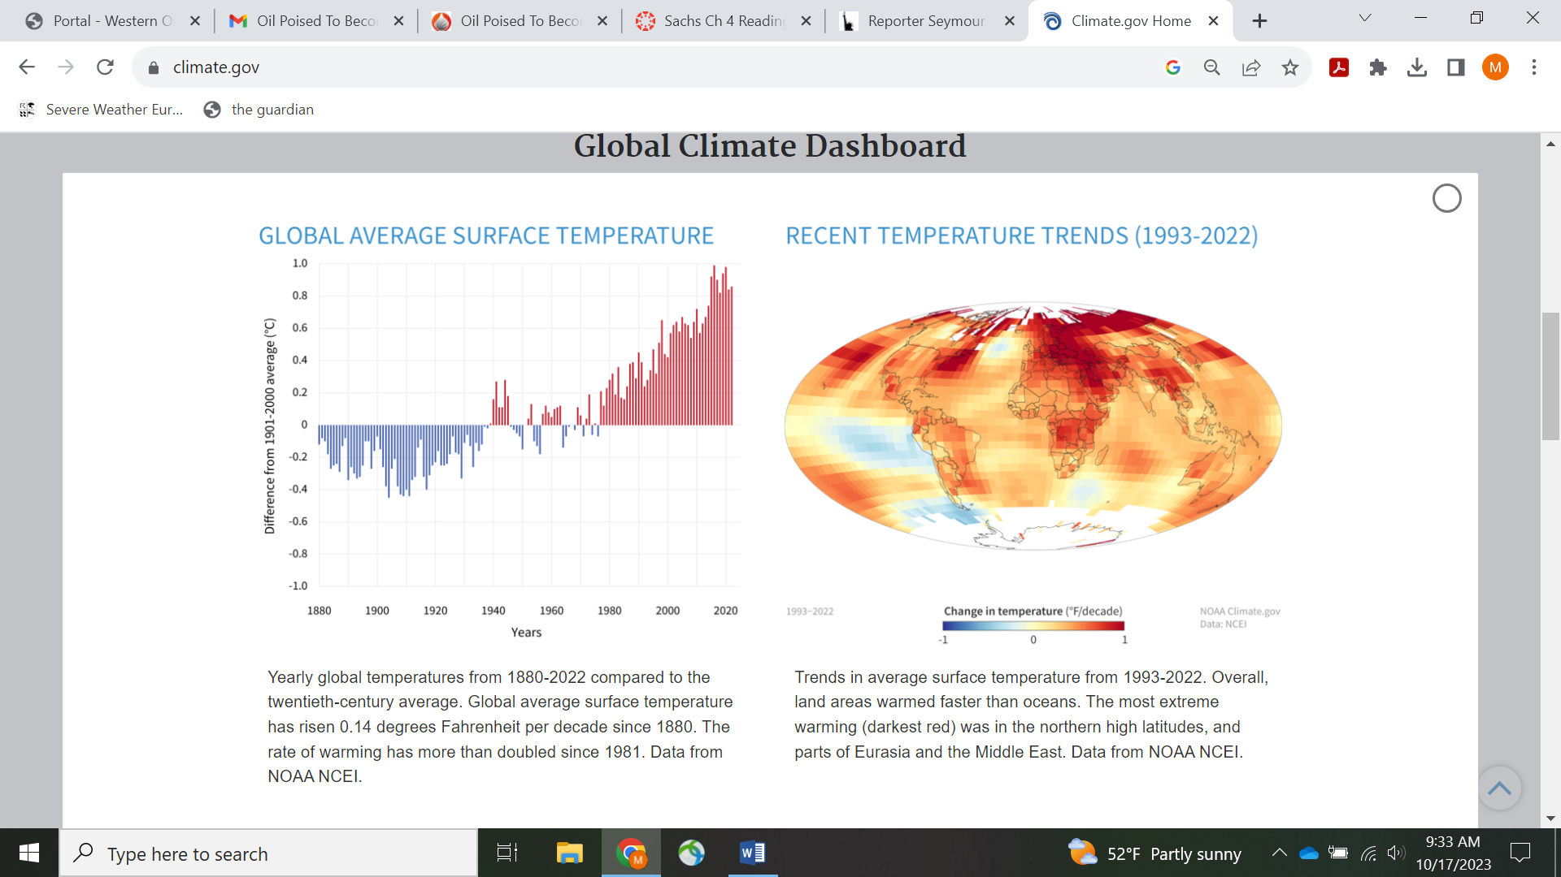

US Oil Production:

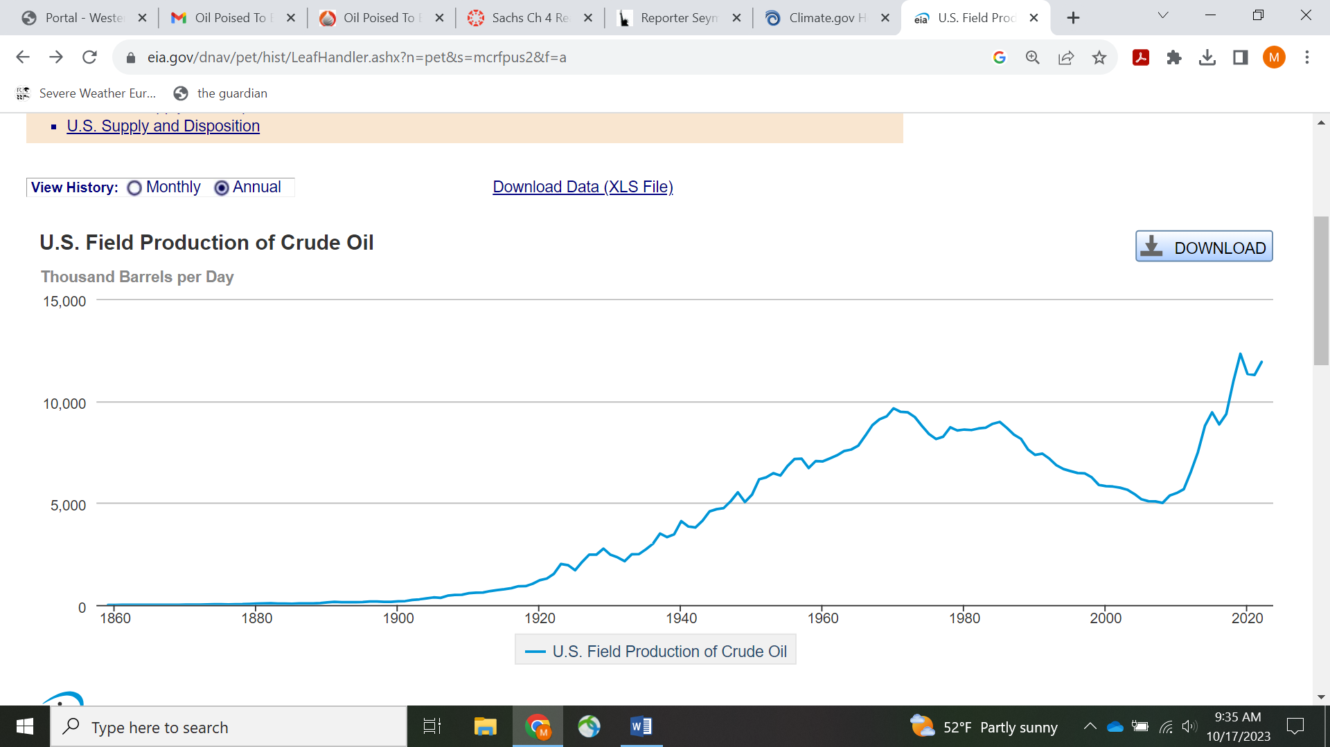

US Natural Gas Production:

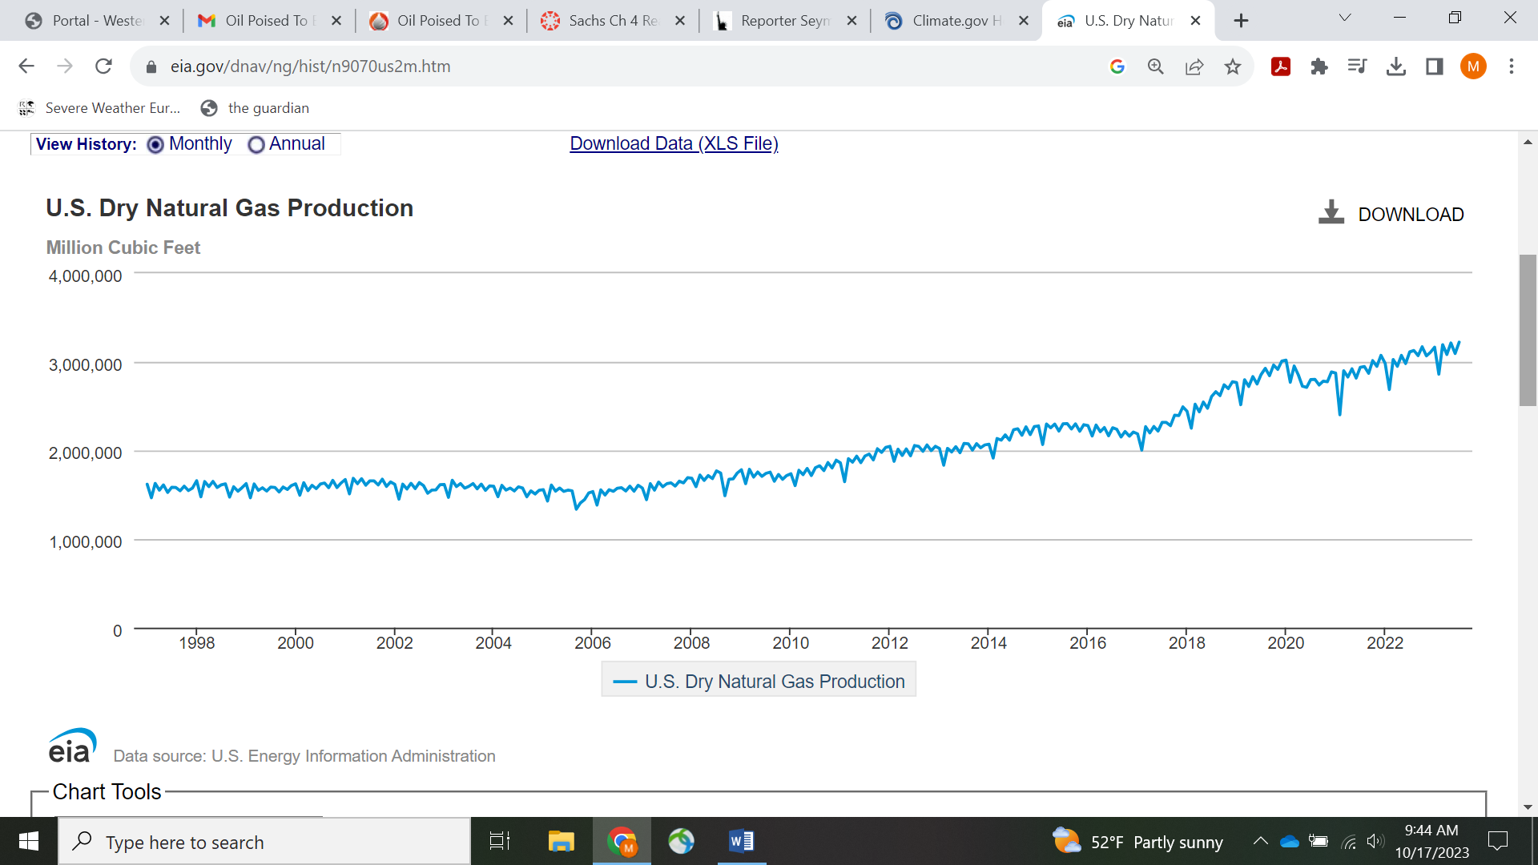

Oilprice.com

**Oil Poised To Become U.S.’ Single Largest Export Product**

Link to this article, if you wish: <https://oilprice.com/Energy/Crude-Oil/Oil-Poised-To-Become-US-Single-Largest-Export-Product.html>

By [Tsvetana Paraskova](https://oilprice.com/contributors/Tsvetana-Paraskova) - Oct 16, 2023, 7:00 PM CDT

* **Since 2015, when the U.S. lifted a ban on crude oil exports – which had previously gone only to Canada – American oil exports have soared.**
* **In the first half of 2023, Europe was the top destination for U.S. crude oil exports by volume, at 1.75 million bpd.**
* **Crude oil is set to become the largest export item for the United States this year for the first time in history.**

[Join Our Community](https://community.oilprice.com/forum/64-oil-general/?utm_source=op&utm_medium=article)

Oil is on track to be the largest export item for the United States this year for the first time in history, highlighting the growing influence of U.S. oil production and exports on the global oil market.

Rising U.S. crude oil production in recent years and growing exports after the ban was lifted in 2015 have made U.S. oil an increasingly important commodity on the market, especially after the Russian invasion of Ukraine and the ban and sanctions on Russian crude in the West.

U.S. oil supply offset some of the OPEC+ cuts in the first half of this year as it is set for record-high production in 2023 and 2024. America's crude oil production is expected to average 12.92 million barrels per day (bpd) this year and 13.12 million bpd next year—new record highs, the Energy Information Administration (EIA) [says](https://www.eia.gov/outlooks/steo/pdf/steo_full.pdf) in its October Short-Term Energy Outlook.

Oil exports are also at a [record high](https://oilprice.com/Latest-Energy-News/World-News/US-Oil-Exports-Hit-Record-In-H1-EIA.html), averaging 3.99 million bpd in the first half of 2023—up by nearly 20% from the first half of 2022.

In terms of both volumes and value, U.S. oil exports were the biggest export of all categories in America's trade with the world through August this year and are likely to be such for the full year 2023—for the first time ever, according to an analysis by [Ken Roberts](https://www.forbes.com/sites/kenroberts/2023/10/15/for-first-time-oil-likely-to-be-top-us-export-in-2023/) at WorldCity, a company that tracks U.S. exports based on U.S. Census Bureau data. [**Related: Airlines: Plan To Phase Out EU Fossil Fuel Subsidies Would Backfire**](https://oilprice.com/Latest-Energy-News/World-News/Airlines-Plan-To-Phase-Out-EU-Fossil-Fuel-Subsidies-Would-Backfire.html)

In August alone, the value of U.S. oil exports, at $10.3 billion, had the [highest share](https://ustradenumbers.com/exports/) of all American exports with 6%, followed by gasoline and other fuels, per WorldCity data. In terms of tonnage, oil's share was also the highest—at 24%, followed by LNG and gasoline and other fuels.

According to the analysis by WorldCity's Roberts published in Forbes, "the primary oil category will be the United States' top export when 2023 figures are released early next year."

Since 2015, when the U.S. lifted a ban on crude oil exports – which had previously gone only to Canada – American oil exports have soared alongside the jump in production. The jump has been more pronounced in the past two years, thanks to a growing global appetite for competitively-priced barrels amid lower supply from OPEC+ and the embargo on Russian crude.

Despite the fact that U.S. crude is mostly of the lighter and sweeter variety, unlike the top grades from Russia and the Middle East, America's exports have been offsetting part of the OPEC+ cuts in recent months.

In the first half of 2023, [Europe was the top destination](https://www.eia.gov/todayinenergy/detail.php?id=60622) for U.S. crude oil exports by volume, at 1.75 million bpd, led by exports to the Netherlands and the UK, the EIA says. Asia came second, taking in 1.68 million bpd, led by U.S. oil exports to China and South Korea. The United States also exported significantly smaller volumes of crude oil to Canada, Africa, and Central America and South America.

In less than a decade since the export ban was lifted, U.S. oil has become so [significant for the global market](https://oilprice.com/Energy/Crude-Oil/US-Crude-Gains-Weight-Against-Global-Oil-Benchmarks.html) that WTI Midland was added in June to the Brent basket of crude oil grades that is used as a benchmark for pricing the world's most traded oil contract.

The reason WTI Midland is becoming more and more important in the Dated Brent assessment is, again, the volume of U.S. crude being shipped abroad, which has averaged around 4 million bpd since the start of the year.

With U.S. oil in demand in Europe and Asia when arbitrage allows, America's oil exports have jumped in the past two years and are set to be the biggest U.S. export item in 2023.

By Tsvetana Paraskova for Oilprice.com

US Future Plans for Oil Production:

Biden Oil and Gas Leases:

<https://www.theguardian.com/environment/2023/sep/29/biden-administration-oil-gas-lease-sale-climate-crisis>

Biden Willow Project:

<https://www.theguardian.com/us-news/2023/mar/13/alaska-willow-project-approved-oil-gas-biden>

A Glimpse of One Part of Geopolitics of Oil

<https://www.democracynow.org/2023/2/15/nord_stream_sy_hersh> View 16:13 to about 26 minutes. Get early quote from Biden, and then opening remarks from Hersh, but please, don’t get too lost in the narrative, which smacks of conspiracy. Mainly just think about the implications of the Biden quote. Why would he say what he said?